**Django**

**What is Django?**

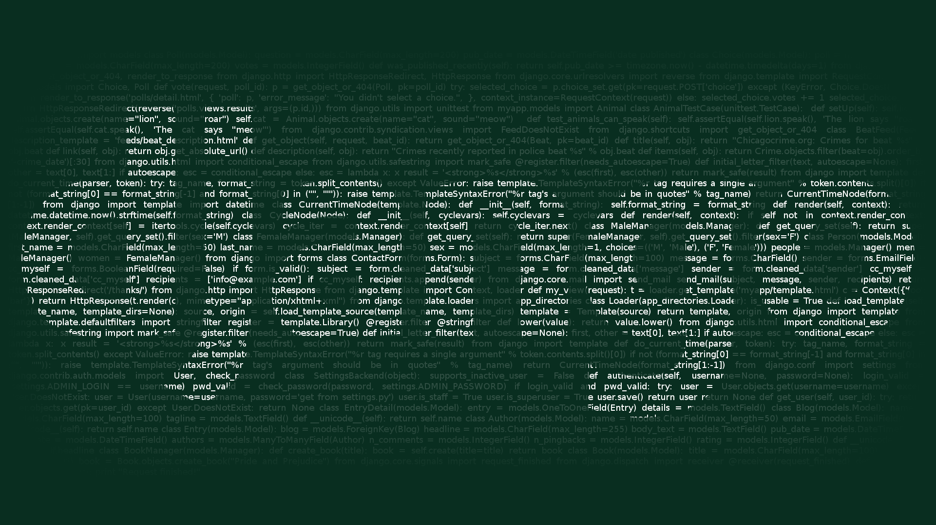

**Django** is an open source high level web development framework which is written in Python. It is a free framework that helps you to work and create website faster and better compared to other frameworks like Flask but it is much easier. Building a website requires lot of components to be integrated and you need to handle user authentication e.g. Sign-in and Sign-out with different forms, panels and to upload local files etc. Django provides you with a set of ready-made components in a framework.

Django Framework saves your time and energy from rewriting code for each and every component from scratch and provides you with built-in functions.

**Why should we use Django framework?**

Django is fast and simple where you can do rapid development in less time. Django has great documentation and follows the principle of DRY (Do not Repeat Yourself) while others don’t care much about it. Django also ORM (Object Relational Mapping) support. Database can be updated through command line Interface using following command,

**`python manage.py migrate`**

And migrations can be generated using

**`python manage.py makemigrations`**

**Django’s MVT Pattern**

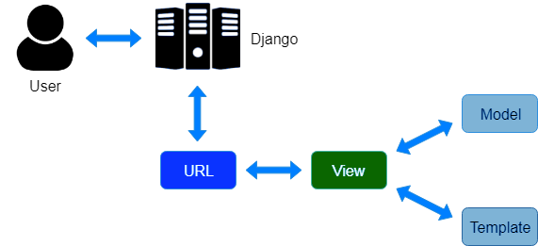

**Django** uses MVT (Model-View-Template) rather than using the old methodology of MVC (Model-View-Controller). MVC pattern is used while creating application with User Interaction. Template in Django consists of HTML code with Django Template Language (DTL). Django Template Language is Django’s template language. Controller is the code written to control the interaction between the Model and View and Django easily takes care of it.

Django takes care of user request using Model, View and Template in a way that whenever a user sends a request Django acts as a Controller to check if it is available by mapping the URL and if the URL maps then it View starts interacting with the Model and sends the Template back to the user in the form of response.

**Django Installation and Setup**

Installing Django is very easy compared to other frameworks but it differs with Operating System. Latest version of Django can be downloaded from their official site <http://www.djangoproject.com/download>.

* Django can be installed in Linux or Mac OS using package manager or using pip install.
* For windows, if Python is already installed in your computer then it should be checked if Python Path is set for system variable. Then extract Django and install it.

Django also supports many database engines and can be set as per your requirement. Django provides you with built-in lightweight server for developing and testing your application.

**Creating your Django Application**

A Django project creates a collection of settings including database configuration, Django specific options and also application specific settings default in the project.

Steps to Create Django application are:

Create a directory where you want to store your Django project and cd into that directory and run the following command

**$ django-admin startproject my_app**

If you look at your directory, following structure will be created

mysite/

manage.py

mysite/

__init__.py

settings.py

urls.py

wsgi.py

**manage.py** lets you interact with this Django project in different ways.

**__init__.py** tells the python interpreter that the directory should be considered as a python package.This file is mostly empty.

**settings.py** is the configuration file.

**urls.py** includes all url declaration for the Django project and table of contents of of Django powered site.

wsgi.py is the entry point for WSGI compatible web servers to serve your projects and deploy with WSGI.

If you want to check, if your project is running you can use run it using following command,

**$ python manage.py runserver**

**How Django makes your work easy?**

Django follows pythonic way that is “Simple is better than complex”. Django one of the python package that is stored inside the site-packages directory of your Python Installation with other important python packages like Numpy, Scipy, Pillow etc.

Simple way to verify if Django is installed and if you are able to import it into your project:

**>>> import django**

**>>> print(django.get_version())**

**Django** provides you with everything that is necessary to develop a full-fledged application. It offers with built-in templating using HTML, URL routing, ORM (Object Relational Mapping), session management etc.

Django also offers number of useful tools for SEO.Using Django SEO framework, Django developers can reduce page loading time using cached templates and by CSS, JavaScript compression. There is also a tool to manage robots.txt.Django CMS capabilities very much exceed expectations of professional SEO specialists.

**Top Companies which use Django** **Framework**

1) Instagram

Instagram is a python based photo and video sharing social networking app which processes huge amounts of data and manages even greater number of interactions between multiple users every second.

Django Framework helps Instagram to handle all these work by keeping it simple and not reinventing the work.

2) Spotify

Spotify has taken music industry to the next level by changing the way people listen to the music and making it accessible to anyone on any device.

Spotify uses Python for both backend services and machine learning combined with Django Framework.

3) YouTube

YouTube is one of the popular content sharing platform. YouTube was a PHP based project but to improve its performance YouTube moved to Django which helps them to act and flawlessly.

4) Dropbox

Dropbox is one of the renowned cloud storage services for documents, videos and pictures. It is based on python for both desktop and server client software.Dropbox use Django Framework to enable storage, synchronization and providing options for sharing various types of files.

5) Mozilla

Mozilla is the most popular and recognizable browser in the entire world which has millions of users worldwide. Their old components are not written in python but the new components are implemented using Django.

For e.g. support sites and add-ons are built using Django. They have shifted from PHP (CakePHP) to Python (Django Framework) which helped them deal with tens, hundreds and millions of views per month and more API hits per day.

6)Disqus

This is the largest project implemented using Django.Disqus developers have built the app from scratch using Django to scale it to handle millions of users per day. They have also used Django in one of their projects called Sentry, an error reporting tool which is also famous with developers these days.

**What can you do with Django?**

You can create web applications using Django that basically requires connection to the database, CRUD (create, read, update and delete) operations, security, user management and creating RestAPI using Django Restful API.

**Django is not PHP**

Django uses Python programming language as it makes things easier for you.It’s a complete framework that uses templating language.

Django has been crowd-tested with many big companies have implemented their enterprise application as well as mobile applications using Django. It has excellent documentation. Docs are a first-class citizens in Django world. It has over 3,000 packages available for users and it is one of the first frameworks to respond to new vulnerability.

**Why do we need Django**

Django is built to help rapid development with clean and practical design. This makes it a first choice when you are building a highly customisable apps. Without reinventing the wheel, Django covers the basics by letting developers focus on the important parts that need to experiment with, such as ability to share different types of media.

Django has solid user authentication model with ability to configure users, this makes Django very first choice when security is a top priority. Django uses a series of Python components that are separate entities which are not dependent on each other.

**When not to use Django**

Django is not the best framework to use in every instance of time. While it has a brilliant foundation for implementing large projects but it often overkill for smaller projects. It should not be used for building a small site, usually the one without the database. Flask framework is mostly used for these kind of small projects.

**Advantages of Django Framework**

1) It is a Python Language

As mentioned Django is written in Python. Python language is a simple to learn and easy to implement language. Python manages more in fewer lines with large libraries.

2)Django and Python are core solutions for Fintech Companies in Silicon Valley, IT giants, Blue chip companies and Internet of things.

3) Administrative Interface

The administration interface provided by Django is simple to create and one of the key advantages using framework. Django gives you fully featured admin interface. For e.g.

class Interface(models.Model):

interface_title = models.CharField(max_length=50)

some_other_text = models.CharField(max_length=100)

some_boolean_value = models.BooleanField()

admin.site.register(Interface)

4) Extensive Support Libraries

It provides libraries that include string operations, web services, operating system interface and standard protocol.

5) Scalable

To handle heaviest traffic, Django is used to meet busiest sites traffic demands. Django allows you to take different actions regarding scalability such as running separate servers for database and even use clustering or load-balancing to distribute application on multiple servers.

**Disadvantages of Django**

1) Specifying URL with regular expressions is not easy task to accomplish for beginners. Template error fails silently where you might waste a lot of time trying to figure out the problem.

2) It gives a monolithic feeling as it is a strongly opinionated framework.

3) Django does not have the capacity to manage different requests at the same time because it does not empower individual procedures to deal with multiple request at the same time. Developers struggle as they need to investigate different approaches to make a single procedure control various requests at the same time.

4) Django’s ORM (Object Relation Mapping) system allows developers to work on different databases at same time but it lacks some features which are essential provided by other ORM systems. It is designed in a way that doesn’t let programmers to use SQLAlchemy completely, which is python’s famous toolkit.

**Prerequisites to learn Django**

1) The basic syntax of Python mostly understanding the indentation part of python if you have worked on other languages.

2) Python function, like how to pass argument in Python function or set a default value.

3) While developing a web application you might require to import different modules, so you need to understand importing of external packages in your code.

4) There is an important entity called Regular Expression (regex) which is mostly used while URL mapping. It is also used to validate the strings. For e.g. if you are asking the users to enter their email-id or password, you need to validate the entered string.

5) Knowledge of RestAPI and JSON is also important which is used as a data structure to store and transfer the data between different network entities.

**How this technology will help you in career growth?**

1) Django is a perfect framework for a beginner to work and explore opportunities in his/her current organization. Python-Django certification is one of the most sought after skills in today’s programming domain.

2) Large organization use Django to develop their project, this will give programmers and web developers to work for best clients in the world.

3) Django is one of the most popular framework in the world which means that a developer who has experience who has good experience in Django can earn a good package with good onsite opportunity while working with great clients all over the world.

**Conclusion**

1) Django framework does bring some trouble but at the same time it also allows you to solve huge number of tasks very quickly and easily. It makes software development using Python cheap and simple.

2) Django ORM has its shortcoming but Django REST framework turns its disadvantages into advantages because the interface that Django ORM provides is best for REST.

3) The huge advantage of Django REST framework is that it has perfect interfacing models but it can also work with bare implementation of Data Mapper patterns.

4) It depends on the team you have to what goals you set for them to use with the help of Django. Django has lot to offer if you are in outsourcing business, your average project does not last more than a year, budget of project is low and deadlines are very short.

5) Django also makes it easy to serialise the data and serve it in XML or JSON format. This is very useful when creating a web service or a web site that purely provides the data to be consumed by other site or applications. In short Django framework is one of the best framework available in the market which is free and simple.